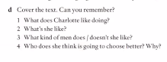

Have/has

Go/goes

Do/does

R:

1.-She loves going to the movies, but she likes to be in her house reading a good book.

2.- she is friendly, and sociable and she gets along well with many people and she has a good sense of humor.

3.-she likes me with a really nice smile, that are into literature and art, that like classical music. She doesn’t like men with a beard.

4.- she thinks her mother knows her better.

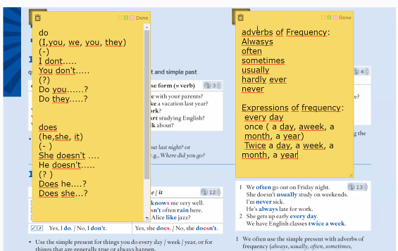

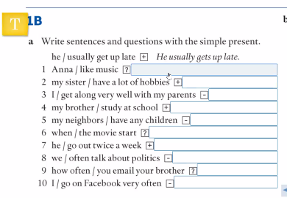

1..-Does anna like music?

2.- My sister has a lot of hobbies.

3.- I get a long very well with my parents

4.-My brother studies at school

5.-My neighbors don’t have any children

6.-when does the movie start?

7.-he goes out twice a week

8.-We don’t often about politics

9.- How often do you email your brother?

10.-I don’t go on facebook very often

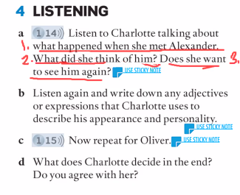

1.- What happened when she met Alexander.

She said that he was tall and dark.

She really liked him, but physically he wasn’t her type.

She noticed that he likes art and literature as her.

She likes only like a friend there was no chemistry between them.

Charlotte said he was a extroverted and funny.

2.- What did she think of him?

3.- Does she want to see him again?

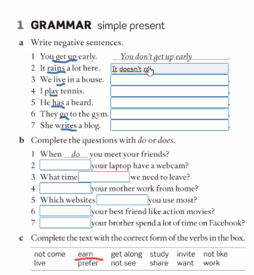

1.-

2.- It doesn’t rain a lot here.

3.- we don’t live in the house

4.- I don’t play tennis.

5.- he doesn’t have a beard

6.- They don’t go to the gym

7.- She doesn’t write a blog.

B)

1.-

2.-Does

3.-do

4.-Does

5.-Do

6.-Does

7.-Does

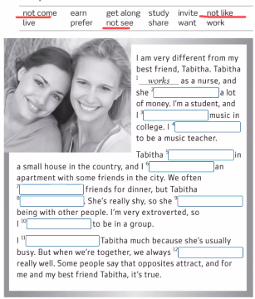2.- earns

3.- study

4.- want

5.- lives

6.- share

7.invite

8.-doesn’t come

9.- doesn’t like

10.- prefer

11.-don’t see

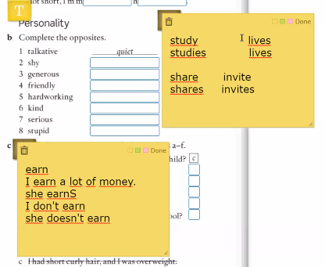12.- get along

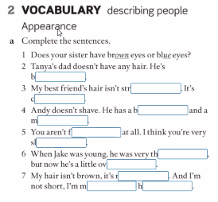

2.-

3.- straight

4.- curly

5.- beard

6.-mustach

7.- fat

8.-slim

9.- thin

10.-over weight

11.-red

12.-medium

13.-height

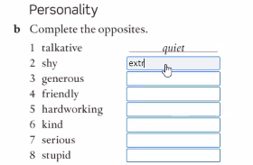

1.-Extroverted

2-Cheap

3.-Unfriendly

4.-Lazy

5.-Unkind

6-Funny

7.-smart

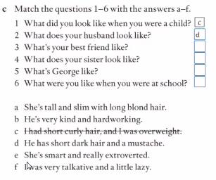

1.- C

2.- D

3.- E

4.- A

5.- B

6.- F

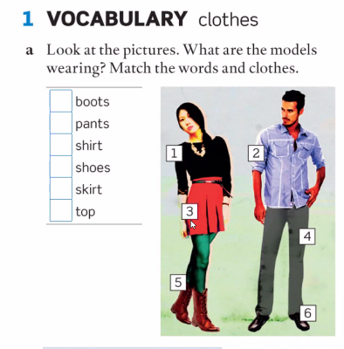

1.-5

2.-4

3.-2

4.-6

5.-3

6.-1

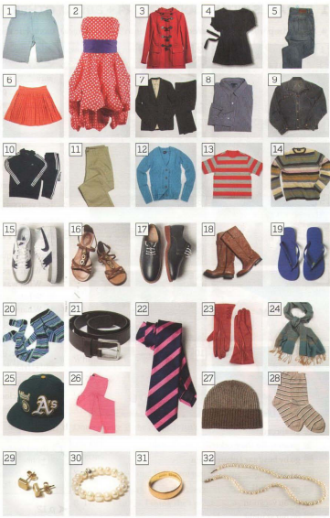

**Clothes**

1.-

12.-Cardigan

3.-Coat

9.-Jacket

5 Jeans

11 Pants

6 Shirt

7 Suit

14 Sweater

4 Top

14 War-up suit

2.-Dress

13.-T-shirt

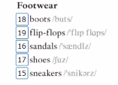**Footwear**

15-. Sneakers

16.- flip-flops

17.-shoes

18.-boots

19.-sandals

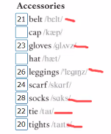**Accessories**

20.-

27.-  
21-belt  
23- gloves  
26.-Leggings  
24.-scarf  
28.-socks

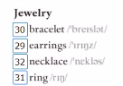22.-tie  
20.-tights

**Jewelry**

32.- neeklace  
29.-earrings

30.-bracalet

31.-ring

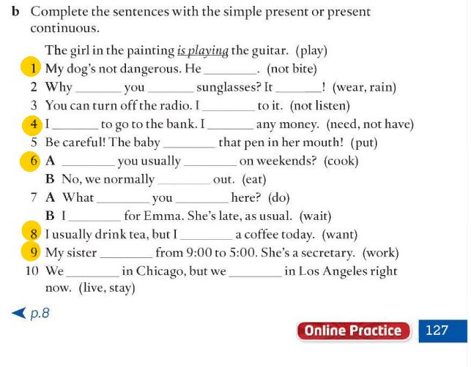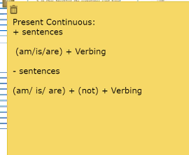

2.- where

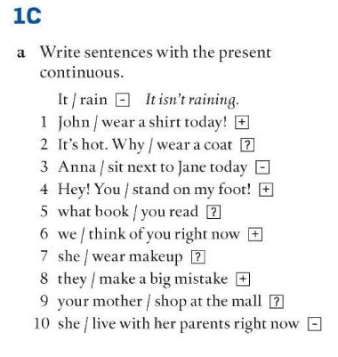

John is waring a shirt today

Why are u wearing

3.-Anna is not sitting

4.- you are standing on my foot

5.-what book are u reading?

6.-we are thinking of you right now

7.- is she wearing makeup?

8.-they are making a big mistake

9.- is Your mother shoping at the mall?

10.- she’s not living with her parents right now

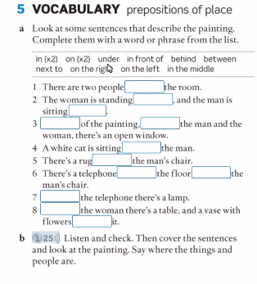1.- in

2.- on the left, on the right

3.- in the middle, between

4.- on

5.- under

6.- on , behind

7.- next to

8.- in front of, in

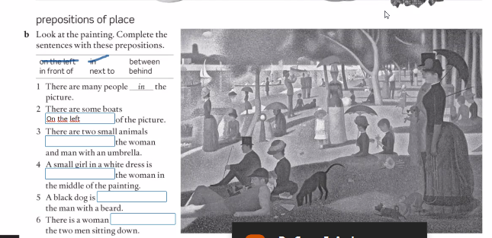

1.-in

2.- on the left

3.-in front of

4.- next to

5.- behind

6.- between

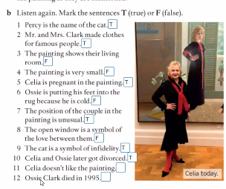1.- T

2.-T

3.-F

4.-F

5.-T

6.-F

7.-T

8.-F

9.-T

10.-T

11.-T

12.-F

